**TITLE: Invasive ungulates are major drivers of forest composition in avian-free novel ecosystems**

**AUTHORS:** Ann Marie Gawel, University of Guam, U.S. Fish and Wildlife Service

Email: [anngawel@gmail.com](mailto:anngawel@gmail.com)

Haldre S. Rogers, Rice University

Email: [hsr@rice.edu](mailto:hsr@rice.edu)

Ross H. Miller, University of Guam

Email: [rhmiller@uguam.uog.edu](mailto:rhmiller@uguam.uog.edu)

Alexander M. Kerr, University of Guam

Email: [alexander.kerr@aya.yale.edu](mailto:alexander.kerr@aya.yale.edu)

**KEYWORDS: *ungulates, invasive species, herbivory, seed dispersal, limestone karst forest, Mariana Islands***

**Abstract**

Conservation has long focused on preserving pristine ecosystems. However, understanding and managing novel ecosystems has grown in importance as these systems begin to outnumber pristine ecosystems worldwide. We examined species interactions in the novel ecosystems of the island of Guam, where native birds have become functionally absent and Rota, a neighboring island that still retains native bird populations. This study focused on the roles of long-established ungulates – Philippine deer (*Rusa mariannae*) and feral pigs (*Sus scrofa*) – on seedling survival, seed dispersal, and plant community structure in limestone karst forests. Ungulates had species-specific effects on seedling survival in unfenced versus fenced seedling plots on both islands; and seedling and vine abundance in nature showed strong negative loglinear correlations (R2 ≥ 0.65) to deer abundance in Guam. These patterns were not detected when correlated to pig abundance, nor were they detected in Rota, where avian dispersal may have obscured relationships between herbivory and seedling abundance. Although pig abundance was not strongly correlated to plant community characteristics, germination experiments revealed that pigs disperse native and exotic species. Even in highly degraded forests with no native seed dispersers, ungulates play important roles in shaping forest composition – deer through herbivory, and pigs through seed dispersal.

**Introduction**

The extent of human influence is so pervasive that the earth today is comprised mostly of novel ecosystems (Seastedt et al. 2008). Novel ecosystems result from anthropogenic influences and have species compositions and relative abundances that have not been previously observed (Hobbs et al. 2009). Species introductions create and maintain novel ecosystems by adding new species and removing native species (Seastedt et al. 2008). Novel ecosystems may be severely degraded and comprised of non-native species, but many still harbor species that serve important ecological functions, and many are good candidates for restoration. However, effective conservation in these systems requires better knowledge of the remnant native and introduced species that comprise them, and their current ecological roles.

Most conservation goals focus on restoring native species to historical abundances, but restoring ecological functions may be more beneficial and feasible for degraded ecosystems (Hobbs et al. 2011). Conservation efforts that have focused on removing invasive species and reintroducing native species have yielded many positive results. However, removing invasive species could have negative consequences if these species play important ecological roles in the novel system (Savaleta et al. 2001). Likewise, reintroducing reduced or extirpated native species may prove unsuccessful or detrimental if persistent threats and current conditions are poorly understood (Hobbs et al. 2011, Godefroid et al. 2011).

Although the negative impacts of introduced species are extensive, some introduced species play beneficial roles (Davis et al. 2011, Schlaepfler et al. 2011). Introduced species can be good candidates for restoring severely degraded habitats (Ewel and Putz 2004). For example, planting non-native trees in abandoned pastures in Puerto Rico facilitated the return of native plant communities where the native plants would not have originally colonized (Lugo 1997). Some introduced species may provide desirable ecological functions such as seed dispersal or food sources for native species (Goodenough 2010). Introduced Japanese white-eyes (*Zosterops japonica*) in Hawaii are seed dispersers for native plants that previously relied on now extinct or rare native birds (Foster and Robinson 2007). Finally, invasive species may slow or reverse negative ecological effects from other anthropogenic impacts. Cascading ecological effects from overfishing in Cape Cod salt marshes are being reversed by green crabs (*Carcinas maenas*), which are normally considered a harmful invasive (Bartness and Coverdale 2013).

The islands of Guam and Rota in the Mariana Archipelago, Western Micronesia, as with many islands around the world, have had a long history of species introductions (Fritts and Rodda 1998). Perhaps the most famous invasive species is the brown treesnake (*Boiga irregularis*), which was unintentionally introduced to Guam on military cargo at the end of World War II. It is responsible for the extinction of most of Guam’s native birds between 1945 and 1985 (Savidge 1987). The nearby island of Rota has retained more pristine karst forest habitats than Guam (Falanruw et al. 1989), however, both islands have experienced many species introductions, including ungulates, which have been established for centuries (Safford 1905, Conry 1989, Wiles et al. 1999). Deer and pigs in the Marianas have had substantial negative effects on the forest. Philippine deer (*Rusa* *mariannae*) density in Guam has been correlated with reduced seedling recruitment in some species of native trees (Wheeler 1979, Schreiner 1997). Feral pigs (*Sus scrofa*) are thought to affect seedling recruitment through physical disturbance of the forest floor and through seed predation (Conry 1989, Ickes et al. 2001). However, these impacts are occurring within unique novel rather than pristine ecosystems, therefore a more thorough examination of the role of each species within the larger ecological context is needed to make appropriate management decisions.

We investigate the ecological role of invasive ungulates in a highly degraded novel ecosystem and in a less degraded system with similar biological history. Because Guam’s forests have effectively lost ecological services provided by avifauna (Rogers 2012, unpublished data), we were able to discern the relative magnitude of impacts from introduced ungulates between Guam and Rota. In the Mariana Islands, birds are especially important for seed dispersal of a number of native forest species (Rogers 2012, unpublished data). Here, we examine the impact of feral pigs and deer on seedling survival, seed dispersal, and overall plant community composition. We contrast their role in the bird-free forests of Guam to that in the nearby forests of Rota which still maintain avian populations.

**Methods**

*Study Area*

Guam (13.45° N, 144.78° E; 540 km2) is the largest and southernmost island of the Mariana Island Archipelago in the Western Pacific. Rota (14.15° N, 145.21° E; 85 km2) is located 76 km north of Guam and has less than 2% of the population of Guam. Both islands have large areas of native limestone karst forest with similar species compositions. These islands contain a variety of habitat types, but karst forests were chosen as the focus of this study because they contain a larger variety of native and endemic tree species relative to other habitats, such as savannah or ravine forest (Fosberg 1960, Raulerson and Rinehart 1991).

*Effect of ungulates on seedling survival*

To assess ungulate effects on seedling mortality, we set up paired plots in karst forest sites in northern Guam and in Rota. Eight sites were selected in Guam and seven sites in Rota. At each site, we erected a 1.8-m tall chicken-wire fence around one plot, and left the adjacent plot unfenced, allowing ungulate access. The fenced and unfenced plots were placed so that individual pairs had similar in canopy cover, rockiness, and surrounding vegetation. Each seedling plot covered an area of about 3.5 m x 5.5 m.

We selected six species for this experiment encompassing a variety of common native and introduced trees found in forests of the Mariana Islands: *Carica papaya*, *Morinda citrifolia*, *Neisosperma oppositifolia*, *Aglaia mariannensis*, *Premna obtusifolia*, and *Psychotria mariannensis*. For each species we collected seeds from at least five trees and at least four different sites to minimize maternal effects and effects of local adaptation. The date of seed collection and subsequent out-planting was staggered by species, in part due to differences in fruiting phenology. After seeds were collected, fleshy fruit was removed, and they were planted in a mixture of 50% perlite and 50% peat moss, and fertilized using Osmocote®. All seeds were planted on the island from which they were collected. The seed trays were placed under 60% shadecloth at a nursery in Guam and at a nursery in Rota, and allowed to grow in these conditions until they had fully rooted and grown their first true leaves. At this point, the seedlings were transported to the exclosure sites for out-planting.

Seedlings of each species were brought to each site and out-planted in the control and treatment areas on the same day. Seedlings were placed at least 0.3 m apart from each other, and at least 0.5 m away from the fences in fenced treatments. On Guam, 14 seedlings of each species were planted in each treatment at each site, except for *N. oppositifolia*, which had only seven seedlings planted per treatment. This gave a total of 1232 seedlings planted in Guam. We were not able to get 14 seedlings for every treatment at every site on each island due to seed availability in the wild. In Rota, nine seedlings of *N. oppositifolia*, 11 seedlings of *C. papaya*, and 14 seedlings of the other four species were planted in each treatment at each site, a total of 1190 seedlings. The seedlings planted during drier months (*C. papaya, M. citrifolia,* and *N. oppositifolia*) were watered regularly during the first few weeks following transplanting to ensure they successfully established. After transplanting, seedlings were monitored monthly for survival until July 2011 (15 months after the first species was transplanted).

*Germination from fecal samples*

We collected feces from *R. marianna* and *S. scrofa* from limestone karst forest sites to determine if either ungulate dispersed viable seeds via endozoochory. Location and date were recorded for each collection. We collected throughout the year, through both rainy and dry seasons from four different sites in northern Guam.

Fecal samples were layered on top of a 50% perlite and 50% peat moss soil mix in germination trays. The trays were kept outdoors at a nursery under shadecloth. *R. marianna* pellets were mixed in at the surface, and *S. scrofa* scat samples were broken up and mixed at the surface. Trays were watered regularly before and after seedlings emerged from feces. Seedlings were then identified and counted. Because the nursery was open air, species that were known to be wind-dispersed or that were common to all germination trays in the nursery (including from other experiments) were not counted.

*Vegetation transects and scat counts*

We conducted vegetation surveys to gather community composition data about karst forest sites across Guam and Rota. We surveyed vegetation at each site using two straight 50-m by 1-m transects, covering a total of 100 m2. At sites with exclosures, transects extended from opposite corners of the exclosure. At sites without exclosures, transects were placed end to end. All plants within the belt transects were identified and recorded. Height was approximated for each adult plant, seedlings were identified and counted, and plants were categorized as vines, trees, ferns, or herbs. Because animal tracks are almost impossible to see in karst forest terrain, and the detectability of other sign such as trails and grazing vary widely even in similar habitats, we determined scat to be the most reliable indicator of ungulateabundance (Schreiner 1997). Fecal groups from *S. scrofa* and *R. marianna* were counted along the vegetation transects. In addition, a GPS device was used to walk, tracing a square enclosing the vegetation transect area. Fecal groups within a 2-meter belt along this square were identified to ungulate species and counted. Each walking transect covered an area of about 800 m2.

*Statistical analyses*

Seedling survival was compared for each planted species between fenced and unfenced plots, using generalized linear models with mixed effects (R statistical software, R Development Core Team 2013). In these linear models, the fixed effects were fencing, species, and island, while site was considered a random effect. Factors were sequentially removed to determine their importance to the simplest fitted model. Species had a strong effect on survival (∆AIC = 296.0), and species interacted with fencing ((∆AIC = 14.3) to affect survival. Therefore, we analyzed species separately with island and fencing treatments as fixed effects and site as a random effect. Factors were considered to have a significant effect on seedling survival if they improved Akaike Information Criterion (AIC) scores by more than -2 (Burnham and Anderson 2004) when included in a linear model.

Selectivity for native or exotic seedlings in pig scat was estimated using indices prescribed in Manly et al*.* (1993). We compared the abundances of species that germinated from scat to their abundances in nature represented by data from vegetation surveys.

To determine if pigs exhibited selectivity for either native or exotic species that germinated from scat, we collected scat from multiple sites on Guam and compared them to vegetation surveys from those same sites. We calculated the Manly Selectivity Index (Manly et al*.* 1993) for native and for exotic species

*B = wi / ∑ wj*,

where *wi* is the selection probability determined by

*wi = oi / πi,*

where *o*i is the proportion of seedlings from scat of either native or exotic seedlings amongst all seedlings from scats from each season (wet/dry), and *πi* is the proportion of native or exotic adult plants at the site. Because nearly all fern spores are dispersed by wind (Tryon 1970), they were excluded from this analysis. Standard error for *wi* was calculated by using

*se(wi) = √ oi (1 - oi) / (utotπi)}.*

where *utot* is the total number sampled (number of scats collected). We used a chi-square test for significance to determine the significance of the difference between *B* values for native and exotic species.

To determine if germination was significantly different between pig and deer scats, a binomial test was run between the total number of seedlings (11) from the 20 deer scats and the total number of seedlings (802) from 20 randomly selected pig scats.

We used linear regression to correlate ungulate scat abundance to forest characteristics measured on vegetation transects. We used deer abundance and pig abundance as separate independent factors, and forest characteristics as dependent factors. The forest characteristics that we investigated were total seedling abundance, native seedling abundance, exotic seedling abundance, and vine abundance. We tested for outliers using R (R statistical software, R Core Development Team 2013). P-values for studentized residuals less than 0.05 would be considered outliers. The most extreme values all had Bonferroni P-values greater than 0.05, so all data were included in analyses. We also determined r2 and P-values for each regression using linear models. To select the best-fit linear models, F-statistics and P-values were also calculated. All calculations and tests were performed using R.

**Results**

*Do ungulates affect forest recruitment?*

Seedling survival in seedling plots varied depending on species, island where they were planted, and fencing treatment. Treatment effects, or exposure to ungulates by planting in unfenced plots, decreased seedling survival significantly in four out of the six species planted (Table1, Figure 1). Survival was significantly lower in unfenced or ungulate-accessible plots for *C. papaya*, *M. citrifolia*, *P. obtusifolia*, and *P. mariannensis* (Figure 1). Fencing had no significant effect on *A. mariannensis* or *N. oppositifolia*. Fencing and island had a significant interaction for *A. mariannensis*, although there was no difference between survival in fenced versus unfenced plots for this species. Fencing and island also had a significant interaction for *P. mariannensis*, which had lower survival in ungulate plots in Guam, but no difference between treatment plots in Rota.

*Do ungulates act as seed-dispersers?*

We collected a total of 20 fecal pellet groups from deer and 31 fecal groups (scats) from pigs from a number of karst forest sites. Because very few seedlings emerged from the deer pellet groups, (binomial test to confirm this resulted in a P < 0.001 for only 11 seedlings to emerge from deer scats), analysis was focused on pig scats, while germination from deer scats is described here. Only four of the 20 deer pellet groups collected had seedlings emerge from them. Eight *C. papaya* seedlings germinated from one pellet group. One *Passiflora suberosa* and one *Vitex parviflora* seedling each emerged from separate pellet groups. In addition, one *Mikania micrantha* germinated from yet another pellet group. However, its seeds may have blown into the seedling tray, as it is a wind-dispersed species (ISSG 2012). Alternatively, the seed could have been ingested accidentally, as this species does not have an edible fruit.

A greater abundance and diversity of seedlings emerged from collected pig scats. Of the 31 pig scats collected from four different sites, 25 scats had seedlings (80.6%), with a total of 1657 seedlings successfully germinating. The species that germinated from pig scats were the native trees *M. citrifolia*, and *Ficus prolixa,* the introduced trees *C. papaya* and *Leucaena leucocephala*,and the introduced vines *Passiflora* spp.*, Chromolaena odorata* and *Coccinia grandis* (Table 4). All of these except for *C. odorata* and *L. leucocephala* have edible, fleshy fruits.

The proportion of native versus exotic seedlings that germinated from pig scat at the nursery was higher than expected during rainy season but lower than expected during dry season, given the proportion of native versus exotic seedlings observed in nature for both sites. This should not be interpreted as an actual dietary preference of pigs, but the result of a combination of factors that include pig dietary preferences, the abundance of seeds per fruit and fruit per tree, and the likelihood of survival after being digested. Most of the germinated species have fleshy and abundant fruits on each plant, and both *M. citrifolia* and *C. papaya* have large numbers of seeds per fruit.

*How does ungulate abundance relate to forest community composition?*

Strong negative loglinear relationships were detected between the following forest characteristics and deer abundance: total seedling abundance (r2 = 0.710, P < 0.001) (Figure 5A), native seedling abundance (r2 = 0.648, P < 0.001) (Figure 5B), exotic seedling abundance (r2 = 0.770, P < 0.001) (Figure 5B), and vine abundance (r2 = 0.751, P <0.001) (Figure 5C). No correlations were detected between these community characteristics and deer abundance in Rota, and no associations were detected between these characteristics and pig abundance.

**Discussion**

Invasive species are normally managed with the goal of control or eradication, but in novel ecosystems with multiple species and factors contributing to ecological changes, a blanket approach may not be wise. Our study shows that a group often managed as a single entity – ungulates – differ in their effects at a species level. Deer abundance in Guam’s forests showed strong negative loglinear relationships with overall seedling abundance, including native and exotic seedling abundance, and vine abundance. When trying to detect similar relationships with pig abundance, on the other hand, no pattern emerged. However, pigs did appear to have a strong role in seed dispersal in Guam, dispersing mostly native seeds while very few seedlings emerged from deer scat.

One of our study islands had a greater history of anthropogenic disturbance, and like other disturbed systems, is likely in a state of decreased ecological resilience (Holling 1973, Gunderson 2000). As expected from a more disturbed ecosystem (Nyström et al 2000), we observed that the shift from an ecosystem with avian ecological functions to one without diminished resilience to at least one additional disturbance – deer herbivory. The patterns we detected in Guam, where ecosystems not only had ungulates, but were absent of birds due to the brown treesnake, were not detected in Rota, although this island is just 40 miles north of Guam with parallel geologic history and with, besides snakes, a similar array of established non-native species.

Seed dispersal is one of the major ecological services lost in the absence of native forest birds and bats in Guam (Haldre 20XX), but our study suggests that feral pigs maintain some level of dispersal of native plants, including for a number of species historically dispersed by birds. In other systems, non-native seed-dispersers can be capable of more damage by promoting the spread of invasive plants, for example feral pigs spreading strawberry guava in Hawaii (Aplet et al 1991). However, in some systems, endozoochorous dispersal by pigs have been documented as dispersers of native plant species on islands where they have been introduced (O’Connor and Kelly 2012). Our results more strongly support the latter case. Although some invasive species were found in fecal groups collected in Guam, native seedlings germinated from collected scat at higher numbers than predicted from numbers found in nature, showing that pigs selectively dispersed native species in Guam.

Feral ungulates are components of novel ecosystems around the world, and although their negative effects are well-documented (Nogueira-Filho et al. 2009, Rooney & Waller 2003, Ickes et al. 2001), there are a few examples where they play beneficial roles (Desbeiz et al. 2011, Klinger et al. 1994). Ungulate eradication is an important restoration tool, especially in island environments where ungulates are considered destructive invasive species (Kessler 2002, Spear and Chown 2009). While this may still be the preferred management tool for Guam’s systems, there may be unintended consequences. These include the release of invasive plant species (Cabin et al. 2000, Coomes et al. 2003) or reduced seed-dispersal (O’Connor and Kelly 2012). Natural resource managers would be aided by discerning which non-native species serve important functions, and which species are solely destructive before implementing conservation actions in a novel ecosystem.

**Literature Cited**

**Table 1.** Significant effects and interactions in generalized linear mixed models. Likelihood ratio tests were used to select the best fit model. For four out of six species, the best model (indicated by **) included treatment by fencing.

|  |  |  |  |
| --- | --- | --- | --- |
| **Species** | **Effects** | **AIC** |  |
| *Aglaia mariannensis* | full | 75.79 |  |
|  | no treatment | 77.27 |  |
| *Carica papaya* | full | 134.7 |  |
|  | no treatment | 182.4 | ** |
| *Morinda citrifolia* | full | 130.1 |  |
|  | no treatment | 141.3 | ** |
| *Neisosperma oppositifolia* | full | 76.05 |  |
|  | no treatment | 74.51 |  |
| *Premna obtusifolia* | full | 95.69 |  |
|  | no treatment | 108.4 | ** |
| *Psychotria mariannensis* | full | 71.98 |  |
|  | no treatment | 88.06 | ** |

**Figures**

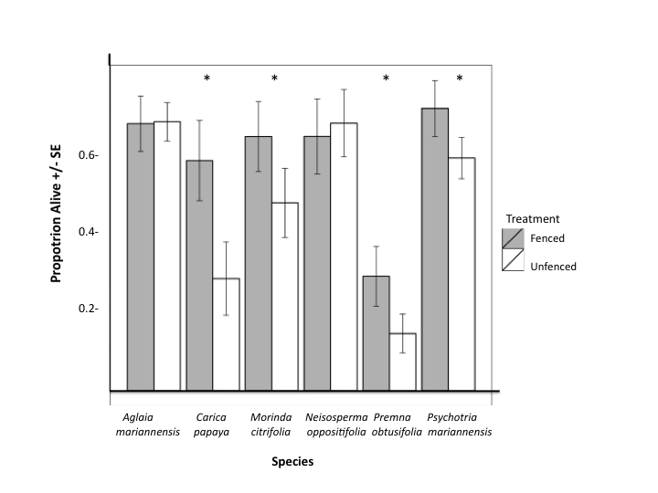

**Figure 1.** Survival in seedling plots.Treatment by fencing or removing ungulate access affected seedling survival, indicated by “proportion alive.” Error bars show one standard error of the mean. Significant effect on seedling survival based on log likelihood ratio test of models with and without treatment.

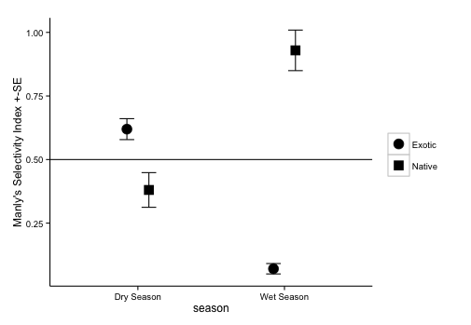

**Figure 2.** Manly Selectivity Index values (*B*) for native and exotic plants during rainy and dry season. During dry season, B was slightly higher, indicating selection for exotic species, but this was reversed during wet season, selection for native species was considerably higher than for exotic species. Error bars indicate standard error defined for selectivity in Manly 1993.

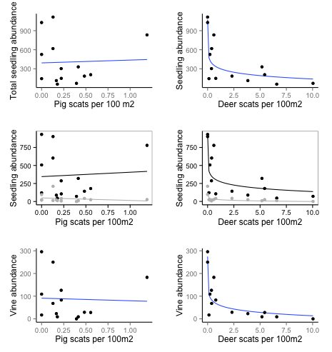

**Figure 3.** No significant correlation could be found between a suite forest community characteristics and pig abundance, as estimated by pig scats. Total seedling abundance related to deer abundance, r2=0.710 with P<0.001; native and exotic seedling abundance, r2=0.647 and r2=0.696, respectively, with P<0.001for each; and vine abundance r2=0.751 with P<0.001.